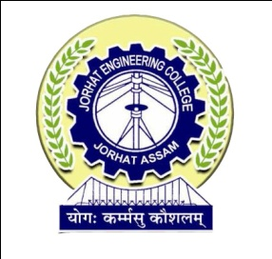

**DEPARTMENT OF COMPUTER APPLICATION**

**JORHAT ENGINEERING COLLEGE, JORHAT**

## **CERTIFICATE**

This is to certify that the project work entitled entitled “e-PANJEEYAN FOR REVENUE & DISASTER MANAGEMENT, GOVT OF ASSAM” is an authentic work carried out at NATIONAL INFORMATICS CENTRE, Assam State Unit , Guwahati is an approved work done by DIPSIKHA PHUKAN (Roll No- MCA 12/16, Reg-No: 13931934 of 2013-2014), a 6th Semester MCA student of Jorhat Engineering College, Jorhat, for the partial fulfillment of the requirement for the award of the degree of Master of Computer Application under Dibrugarh University, Dibrugarh from Jorhat Engineering College, Jorhat.

I wish her success in all future endeavours.

### (Joydip Kumar Sarmah)

Head of the Department

Department of Computer Application

Jorhat Engineering College

Jorhat, Assam

Date:

Place: